Elmbridge Canoe Club – Canoe Time Trial

Hosts: Elmbridge Canoe Club
Date: 4th October 2015

Location:
Elmbridge Canoe Club
Dorney Gardens
Walton Lane
Weybridge
Surrey
KT13 8LU

RESULTS
Name | Club | Time | Class | Boat | Position
Nick Adnitt | Independent | 1:46:36 | Open C1 sit&switch – male | The Darkness | 1
Ross Pearton | Independent | 1:52:36 | Open C1 sit&switch – male | WWR | 2

The seventh race in the series was hosted by Elmbridge Canoe Club in conjunction with their Hasler races.

The weather conditions were perfect, a sunny day, still and not too hot. The river was calm except for a few cruisers and loads of rowing boats, and the trees had not yet shed their leaves.

Ross Pearton used the event as a warm-up for a race at Chester. He shot off the start in a white water racer and headed for Sunbury lock. Nick Adnitt chased after him a minute later but did not overhaul Ross until the portage.

In a boat with a wide open cockpit, Nick was quicker over the portage and set off to the turn. A quick 180 degree turn, and we were set for the finish.

Once back over the roller at Sunbury, the last effort was the Desborough channel to the finish.

Next and last is Banbury Hasler on Sunday 25th October.

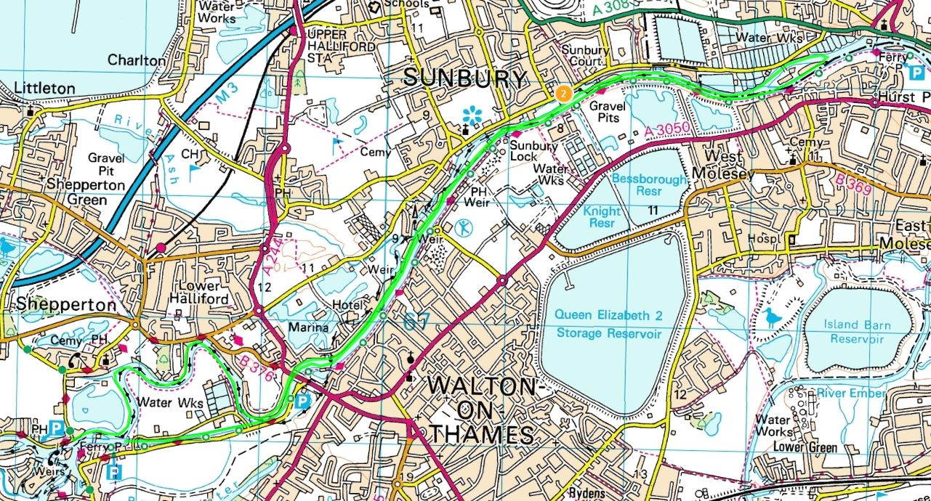
The course

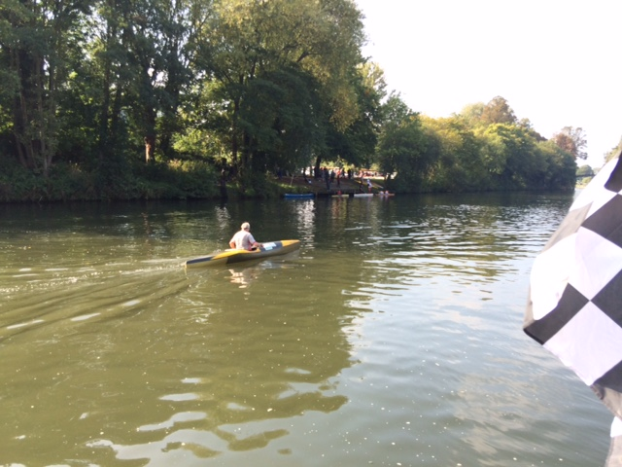
Ross Pearton crosses the finish line

end

