Leighton Buzzard Canoe Club – Canoe Time Trial

Hosts: Leighton Buzzard Canoe Club
Date: 21st June 2015

Location:
Leighton Buzzard Canoe Club
Cedars School / Tiddenfoot Leisure Centre,
Mentmore Road,
Leighton Buzzard,
LU7 2AE

RESULTS
Name | Club | Time | Class | Boat | Position
Stephen Windmill/Pete Jones |  | 01:43:04 | Male C2 open | Wenonah ICF? | 1
Richard Crooks |  | 01:55:39 | Male C1 | high-kneeler | 2

The race was hosted and run by Leighton Buzzard Canoe Club in conjunction with their Hasler event.

The course was particularly challenging as the sides of the canal at Leighton Buzzard are vertical, and notorious for refracted waves and rough water. This was compounded by the number of portages, six out and six back. Although portaging is fun, it clearly increased the race times.

The series saw its first high-kneeler C1 competitor in the shape of Richard Crooks, a highly experienced paddler. I have zero envy, but huge respect for high-kneelers and it must have been especially gruelling to traverse all those portages.

Also up for the event was Pete Jones, this time teaming up with Steve Windmill for the first male C2 entry.

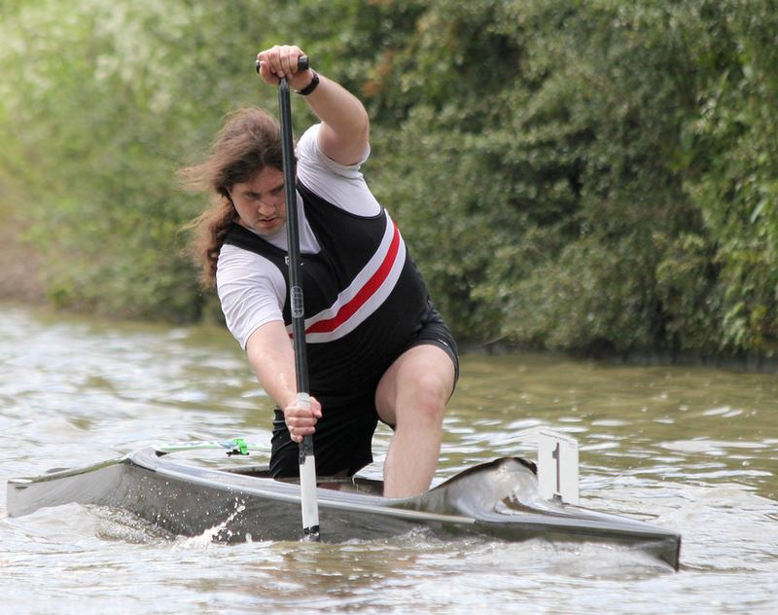

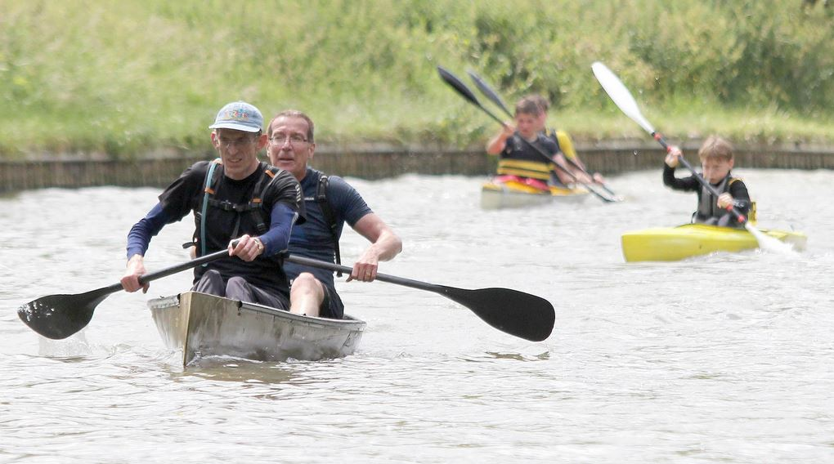

The boats started adjacent to Tiddenfoot Leisure Centre. They negotiated Grove Lock and then Church Lock, (where they crossed the bridge and the towpath changes sides). Then onto Slapton Lock, Horton Lock, then locks 32 and 33. These are close together and some competitors found it quicker to run them. They carried on to bridge 123 at Ivinghoe, where they turned and came all the way back.

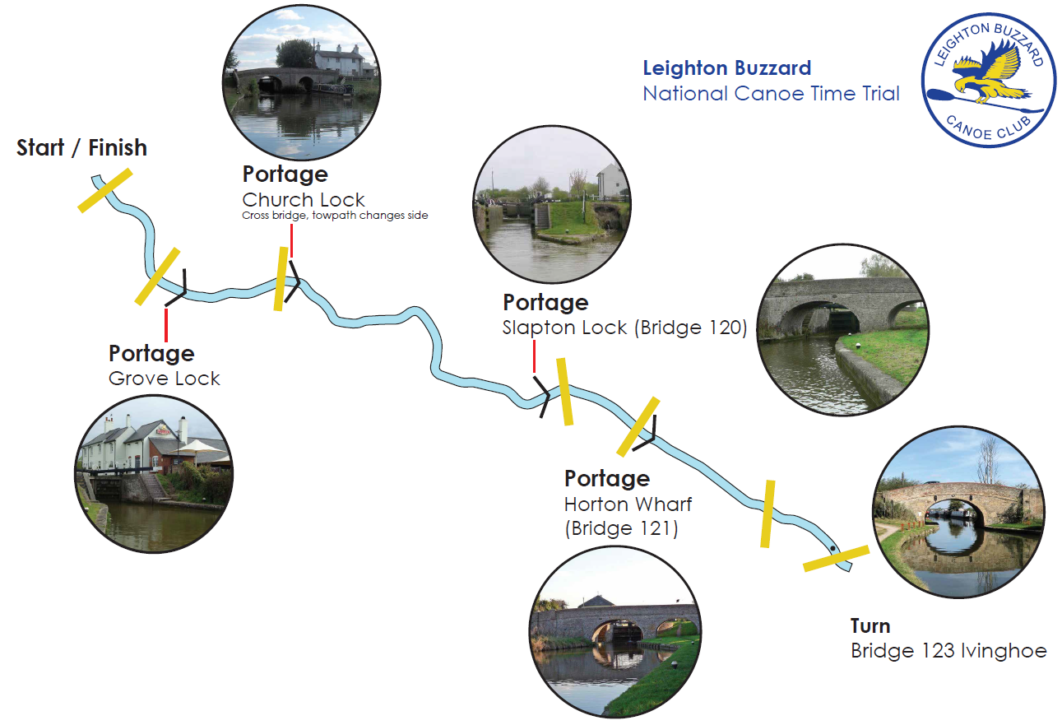

end

