**Reading Canoe Club – Canoe Time Trial**

Hosts: **Reading Canoe Club**

Date: **31st May 2015**

Location:

**The Warren,**

**Caversham,**

**Berkshire,**

**RG4 7TH**

**RESULTS**

|  |  |  |  |  |  |
| --- | --- | --- | --- | --- | --- |
| **Name** | **Club** | **Time** | **Class** | **Boat** | **Position** |
| Liz Murnaghan  Vicky Metcalfe | Basingstoke CCC  Falcon CC | 1:40:26 | Open C2 sit&switch – female | George Oliver Mk 2 | 1 |
| Pete Jones | Independent | 1:47:09 | Open C1 sit&switch – male | Wenonah J203 | 2 |
| Lucy Perry | Falcon CC | 2:03:25 | Open C1 sit&switch – female | The Darkness | 3 |
|  |  |  |  |  |  |

The race was hosted by Reading Canoe Club which was running a series of K4 races.

The weather conditions were quite chilly for late May. It was breezy with intermittent rain, and the temperatures at around 14 degrees. Overnight rain had not had chance to affect the river flow, and the current on the Thames was sluggish.

The highly experience C2 pair of Liz Murnaghan and Vicky Metcalfe decided to get back into the George Oliver Mk2 boat to set a time for the female open C2 sit &switch class. These ladies had completed the Devizes to Westminster (DW) canoe straight through race this year, and have a lot of Hasler race familiarity.

Pete Jones also fancied a competitive paddle, the first since winning the C1 4-day class in this years’ DW. Pete was paddling the Wenonah J203.

Back again was Lucy Perry in The Darkness C1, looking to better her time from the previous event at Worcester.

First off at 10:31 hrs was Pete Jones, followed by Lucy Perry, with the C2 bringing up the rear. By the time the competitors had reached the first portage at Mapledurham Lock at the 4.5 mile point, the C2 had overhauled the two C1s, and Pete had opened a gap on Lucy.

After the turn at five miles, it was back down stream, over the portage again, and the long haul to the finish. Although there was some benefit from the current, a stiff head wind negated some of the advantage.

The paddlers were able to witness ten K4s “steaming” towards them as they made their way to the finish.

Lucy commented that Reading was a harder course than Worcester, resulting in a ten mile time of eight minutes slower. However some of that was due to the two portages across a lock, rather than a single “false” portage at Worcester.

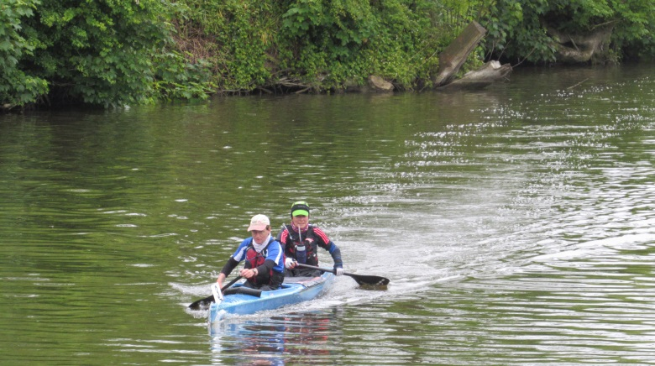 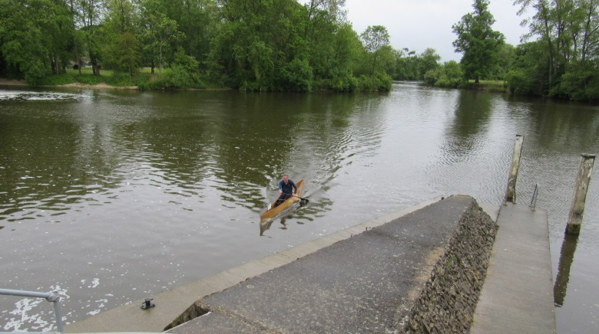

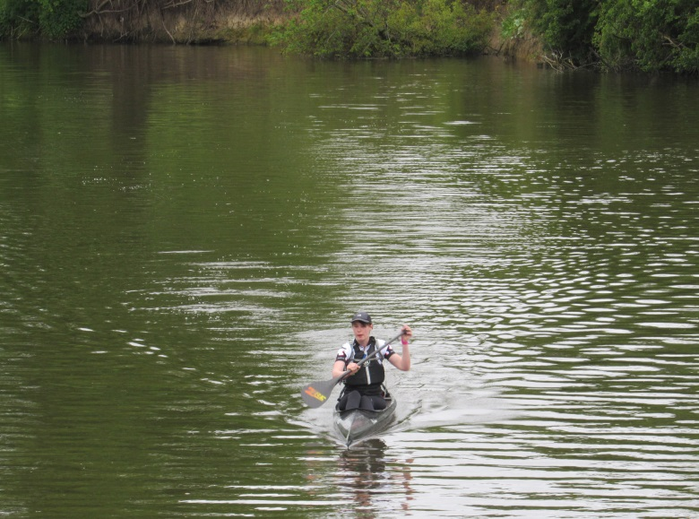



*🡨 end 🡪*