**Soar Valley Canoe Club – Canoe Time Trial**

Hosts: **Soar Valley Canoe Club**

Date: **13th September 2015**

Location:

**Soar Valley Canoe Club.**

**Leicester OPC,**

**Loughborough Road,**

**Leicester**

**RESULTS**

|  |  |  |  |  |  |
| --- | --- | --- | --- | --- | --- |
| **Name** | **Club** | **Time** | **Class** | **Boat** | **Position** |
| Andy Cook  Andy Penhallurick | Solihull CC | 1:50:02 | Open C2 sit&switch – male | Wenonah ICF | 1 |
|  |  |  |  |  |  |

The sixth race in the series was hosted by Soar Valley Canoe Club in conjunction with their Hasler races.

The weather conditions were favourable, sunny and about 14 degrees with hardly a breeze.

The ten mile course twisted and turned along the river Soar, Grand Union Canal and river Wreake. There were three portages out, and three back.

Andy Cook and Andy Penhallurick paddled a Wenonah ICF C2 and completed the course in one hour fifty minutes. An impressive time considering the challenging nature of the portages and the high banks to get in and out.

Next up is Elmbridge Hasler on Sunday 4th October.

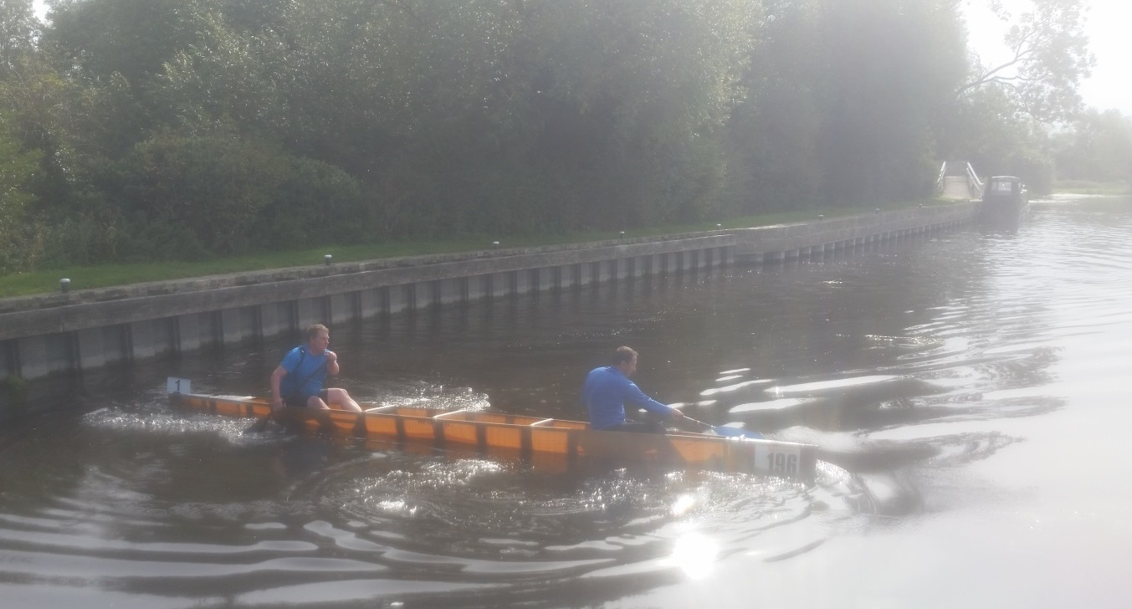

Andy and Andy at the turn



*🡨 end 🡪*