UK Canoeing

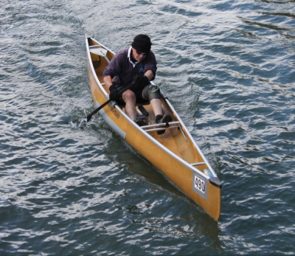 | 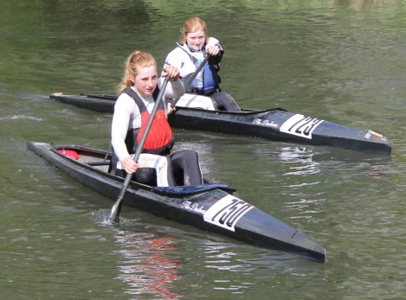 | 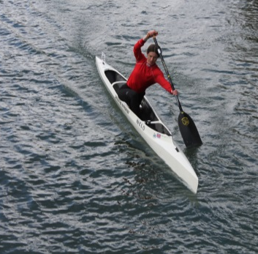

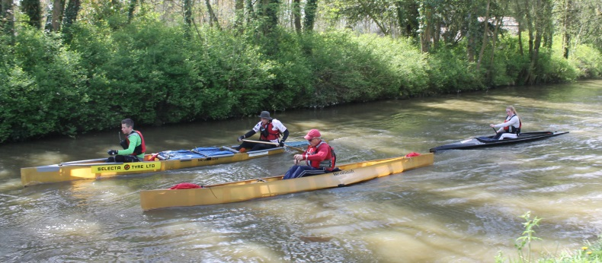 | 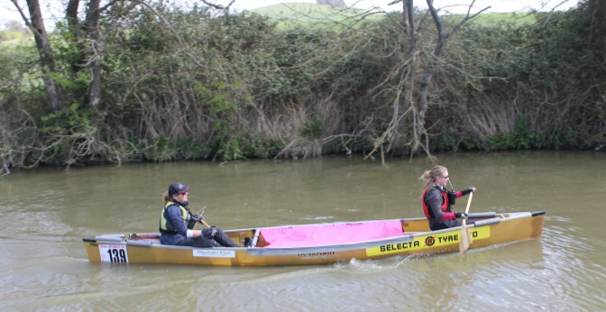

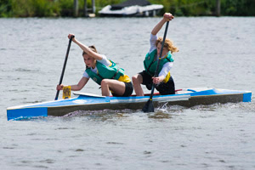 | 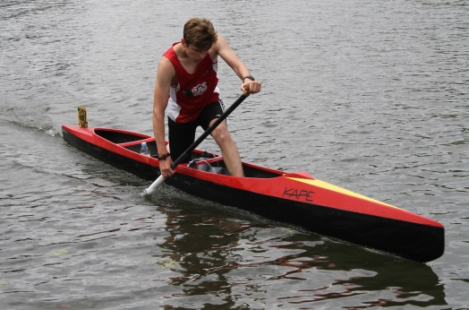 | 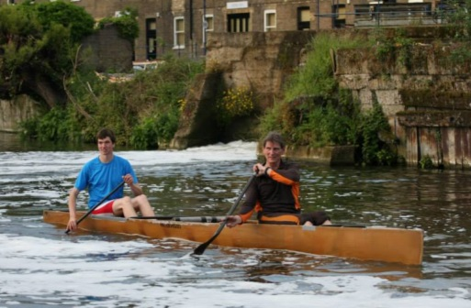

National Canoe Time Trial series
RULES

VERSION: 1.0
Dated: 19th March 2015

Prepared by: Nick Adnitt
6 Dove Close
Andover
Hampshire
SP10 5PB
Email: nickadnitt@aol.com
Mobile: +44 (0)7824 327725

Introduction
This document describes the rules and regulations for a canoe time trail event based on a national standard.

All feedback, ideas, advice and guidance is welcome and should be directed to Nick Adnitt – nickadnitt@aol.com

Document Control
This is an open document. It is not commercially sensitive and does not contain any proprietary or protected information.

Revision History
Version | Date | Author | Changes
1.0 | 19th March 2015 | Nick Adnitt | Original document

Document Distribution
This document have been distributed to a number of recipients.

Name | Contact
Nick Adnitt | nickadnitt@aol.com
James Hinves | james.hinves@canoe-england.org.uk.
Various British Canoeing Marathon Racing Committee including:
Graham Warland | graham.warland@virgin.net
Steve Missen | Steve.Missen@monahans-fsl.co.uk
Diane Bates | diane@bateshome.co.uk
James Smythe | james7270@me.com
Alan Laws | alanlaws46@googlemail.com

Contents
1. Introduction 2
2. Document Control 2
2.1. Revision History 2
2.2. Document Distribution 2
3. Canoe Time Trialling 4
3.1. Definition 4
3.2. Race entry 4
3.2.1. Entry fees 4
3.3. Event information 4
3.4. Race Registration 5
3.4.1. Race categories 5
3.4.2. Start list 5
3.5. Race Control 5
3.6. Officials 5
3.7. Race Numbers 6
3.8. Setting out the field 6
3.8.1. Principles 6
3.9. Pre-start area 6
3.10. Personal floatation 6
3.11. Liability 6
3.12. The Start 6
3.13. Finish 7
3.14. Timing 7
3.15. Boats 7
3.16. Paddles 7
3.17. Overtaking 7
3.18. Wash Hanging 7
3.19. Assistance to Competitors 7
3.20. Portage Aids 7
3.21. Race retirements 7
3.22. Turning Point 8
3.23. Portages 8
3.24. Course Measurement 8
3.25. Results 8
4. Risk assessment 8
5. Roles and Responsibilities 8
5.1. Mandatory officials 8
5.2. Additional officials 8
6. Glossary 8

Canoe Time Trialling
This section describes the rules, regulations and organisation which must be adhered to for an event conforming to the national canoe time trial standard.

Definition
A canoe time trial is the individual effort of a boat over a set course distance, timed from start to finish.

Race entry
Each event will be announced in advance on the NCTT web site (currently hosted by Darkside Canoes). An entry form will be available to download. If the entrant is under 18-years-old the form will need to be countersigned by a parent, guardian or responsible adult.

The entry form details will include: (for both paddlers in a C2)

- Full Name (details of both paddlers required)
- Club (or Independent)
- BCU/SCA/WCA/CANI membership number
- Date of Birth
- Name and designation of counter signature if under 18
- Name of event
- Date of event
- Host club
- The event class in which they are racing; C1, C2
- Gender
- Address
- Email address
- Contact number
- Telephone number of phone in boat
- Boat details:
  - manufacture
  - model
  - dimensions (length and maximum beam)
  - weight
- Signature and date
- Any special requirements

Entry fees
The entry fees can be paid in advance by cheque or electronic funds transfer. Alternatively, race fees can be paid at Registration in cash or with a cheque.

Late entries will be accepted up until half an hour before the start of the first boat. An entry form must be completed.

Event information
Information about the event must be published on a web site at least four weeks before the race date.

The information must include:

- Name of Event
- Date of Event
- Host Club
- Deadline for advanced entries
- Race fees
- Organisers contact details:
  - Name
  - Address
  - Email
  - Telephone number
- Start location
- Start time of first boat
- Parking arrangements
- Registration details
- Course details (including OS map)
  - Start point
  - Finish
  - Description
  - Pre-start area
  - Turn point
  - Portage descriptions and diagrams
  - Special instructions
- Facilities
  - Changing rooms
  - Showers
  - Toilets
  - Refreshments

Race Registration
All competitors must register in person before they start, at the Registration Desk. They will collect their race number, complete the sign-on sheet, and read any briefing instructions. Each boat must have a mobile telephone on-board. The telephone number must be recorded at Registration.

Race categories
Canoes can enter the following race categories:

- Open C2 – male. Any type of C2 paddled by two male competitors.
- Open C2 – female. Any type of C2 paddled by two female competitors.
- Open C2 – mixed. Any type of C2 paddled by one male competitor and one female competitor.
- Open C1 – sit&switch. Any type of C1 paddled in a sitting or low kneeling position.
- ICF C1 high kneeling – male. A C1 in accordance with ICF boat regulations for marathon events, paddled by a male competitor in the high kneeling position.
- ICF C1 high kneeling – female. A C1 in accordance with ICF boat regulations for marathon events, paddled by a female competitor in the high kneeling position.

Start list
A start list must be complete which shows the order of start, and the names of the paddles.

A copy of the start list with boat numbers and the names of the paddlers should be available to key officials before the first competitor starts.

- Time keeper
- Starter
- Finish Judge
- Turn Marshall
- Portage Marshall
- Roving Marshall

Race Control
The race will be controlled from the start point.

A named individual (Race Controller) is ultimately responsible for decisions affecting the race. The Race Controller will be contactable by mobile phone (coverage permitting) during the race.

Officials
A TT can be run with the following minimum number of officials:

- Race Controller – who is ultimately responsible for the race, but can fulfil other roles.
- Turn Marshall – responsible for directing boats around the far turn.
- Starter – responsible for starting each boat at the allotted time.
- Finish Judge – responsible for determining when a boat has finished and recording the finish time.
- Timekeeper – responsible for recording the start time of each boat.

Additional roles include:

- Roving officials – responsible for good conduct and checking any wash-hanging rule infringements.
- Portage Marshalls – responsible for directing competitors over the portage.

Race Numbers
Each boat will be allocated a number. Boats will start in numerical order. The number board must be clearly visible to the start and finish judges.

The number board is collected at registration, and must be returned to Race Control once the boat has completed the course or retired.

Setting out the field
The order that boats start should be set out to avoid as much as possible, the temptation and opportunity to wash hang.

Principles
The following principles should be applied when setting out the field:

- Known fast crews should be split by at least one slower competitor.
- Known or self-declared slower crews should be allocated the earliest start times
- Crews who paddle for the same club should be split by at least one boat.

Pre-start area
Competitors will be required to be ready on the water in the pre-start area at least five minutes before their start time. Paddlers may receive a last minute briefing or reminders.

Personal floatation
Paddlers under 14 years of age must wear a buoyancy aid.

The organiser reserves the right to mandate the wearing of buoyancy aids for all paddlers as appropriate to local conditions.

Liability
All competitors remain responsible for their own safety, and must decide whether the course is within their own ability, from all the information supplied and their own experience.

In all cases competitors compete at their own risk. Neither the Race Organiser, the BCU nor the ICF can be held responsible for any injuries or material damage sustained during the race or on the competition course.

The Start
The start will be from a designated point. The start shall be marked. The stern of the boat will be held until the start. The boat will be stationary up until the starter says “Go”. The time will commence when the starter says “Go”.

The starter will indicate 15, 10, 5 seconds to start. The last five seconds will be counted down to zero (Go). In the event of a false start (determined only by the Starter), the boat will be able to proceed but will incur a 10 second penalty.

Competitors will start in number order at one minute intervals. Competitors must unsure they are ready to start at their allotted time. Competitors who miss their start, will start as soon as they are ready, but the clock will have assumed to have started at their allotted time.

The course
The course will follow the main navigation unless otherwise directed. It is the responsibility of the crew to know the course.

The standard course will be five miles in one direction to a turning point, and then five miles in the other direction.

Alternatives can be offered if a standard course is not practical, but the start and finish must be within half a mile of each other as the crow flies.

Finish
The finish line must be clearly defined.

The timekeeper/s must be located at the finish line well before the first boat is expected.

The clock will stop when the bow of the boat crosses the finish line. The boat must be upright and contain all paddlers, paddles and fittings.

An audible signal must be given to indicate that a competitor has crossed the finish line.

All competitors must be accounted for by the Finisher.

Timing
All crews will be timed from start to finish. Two stop watches will be used to time the race. They must be synchronised to start at the same time. The start time will be zero hour. The boat with race number 1 will start one minute after zero hour, number 2, two minutes are and so on.

Boats
A competitor/s must not change boats during a race.

Boats must be checked before the start to ensure they are safe and have adequate buoyancy. Boats deemed not safe or have insufficient buoyancy will not be allowed on the water to race.

Any type of canoe can be used. Canoes shall be propelled solely by means of single bladed paddles. The paddles must not be attached to the boat in any way, being supported only by the hands.

Paddles
Competitors may take a change of paddle from the bank in the event of a breakage. Competitors may change paddles during a race as long as the spare paddle is on board. The discarded paddle must stay on board for the duration of the race.

Overtaking
Paddlers must not deliberately impede the overtaking boat. Crews preparing to overtake a slower boat must indicate in advance, which side they intend to pass on.

Wash Hanging
Competitors must not hang on the washes of any other vessel on the water. It is the responsibility of the crew being overtaken to drop back from the wash of the overtaking craft.

Any overt wash hanging observed by a Marshal will subject the crew to a time penalty.

Assistance to Competitors
As the race distance is restricted to ten miles, it is unlikely that crews will require Bank Support. However, a competitor may receive food and drink during a race. Competitors with a disability may receive assistance at portages, but no other assistance unless permitted before the race by the organiser.

Competitors must render assistance to any paddler who is in distress.

Portage Aids
Wheels can be used during portaging as long as they are on board for the duration of the race.

Race retirements
Boats retiring from the race must inform Race Control as soon as possible.

Crews must ensure that their boat and all equipment is recovered.

When the last boat has turned, the Turn Marshall will paddle/walk/cycle back down the course to ensure that all boats have finished.

Turning Point
The turning point will be managed by at least one Marshall.

The turning point will be designated by:

- A canoe/kayak around which the competitors must pass.
- A fixed buoy around which the competitors must pass.
- A marked position on the bank which competitors must first pass before turning.

The turn must be negotiated anti-clockwise unless it is unsafe to do so.

The turning point can be land based and as part of a portage.

The Turn Marshall will wait until the last boat has passed before moving to the finish along the water course. He will follow the last boat to the finish. He will ensure that all boats pass the finish line or retire.

Portages
There should be at least one portage.

Course Measurement
The course will be accurately measured using an approved method such as:

- Large scale Ordnance survey map
- Measuring wheel along the towpath/bank.
- Ordnance survey map on the Internet.

Results
As soon as a competitor’s time is known it must be posted together with the start number, in a prominent position, in some consistently perceptible form.

The organiser must, as soon as is practical and within 5 days of the event, send the complete and official results to NCTT web master for publication.

Risk assessment
A risk assessment of the course should be conducted before the first competitor starts.

Roles and Responsibilities
A number of officials are required to organise and run a canoe time trial.

Mandatory officials
There are a designated minimum number of official roles required to run a canoe time trial. Some roles can be taken on by one person, For example, the Starter could also be the Finish judge if there is sufficient time from them to get from the start to the finish whilst the race is being run.

The Registration clerk could also fulfil another role once registration is complete, the field is set out and the start sheets completed.

Registration clerk
The Registration clerk will be responsible for the accurate administration of competitor and crew details.

His/Her responsibilities include:

- Registration of all competitors and crews before the race.
- Check current and valid BCU membership credentials.
- Spare copies of blank entry forms should be available, including pens to complete them with.
- Ensure that the entry forms are completed and signed.
- Completed entry forms must be collected and secured.
- Money and cheques for fees should be taken, recorded and any cash secured.
- At least six copies of the start list should be completed and distributed to the main race officials.
- Close entries half an hour before the first start time.

Race Controller
The Race Controller is ultimately responsible for the race.

His/Her responsibilities include:

- Makes timely decisions and communicates with other race officials.
- Meets all race officials and deliver a standard briefing, plus any specific or local considerations.
- Records names of officials, designation and mobile telephone numbers.
- Ensures each official has an aide memoir and checklist.
- Ensures that the Start point is marked.
- Ensures the Finish line is marked.

Timekeeper
The Timekeeper records the start time of each boat, collects the finish time sheet, and calculates elapsed times.

His/Her responsibilities include:

- Ensures they have an accurate start list.
- Is at the start point at least fifteen minutes before the first boat starts.
- Ensures that the timing clocks/watches are available and working.
- Liaises with the Starter

Starter
responsible for starting each boat at the allotted time.

His/Her responsibilities include:

- Ensures that boats start in the correct numerical order.
- Handles late starters.

Turn Marshall
responsible for directing boats around the far turn.

His/Her responsibilities include:

Finish Judge
responsible for determining when a boat has finished and recording the time

His/Her responsibilities include:

Additional officials

Portage Marshall

His/Her responsibilities include:

Roving Marshall
The Roving marshal’s role is to observe and to witness the actions of competitors whilst taking part in an event.

His/Her responsibilities include:

Glossary

Wash hanging
Wash hanging is the art of using the side or stern wash (or wake) of a boat to assist speed. This allows a paddler to move at the same rate as the lead paddler with considerably less effort (for the skilled paddler). From a single boat there are 3 washes which can be ridden by another boat
left and right side washes – where the bow of the boat riding the wash will typically be around the same level as the cockpit of the lead boat. This is the most effective wash, and is the wash favoured by flatwater paddlers – however it is the more difficult wash to sit on in a river boat as it causes the boat to steer towards the lead boat. Ensure that the paddler sits far enough out so that the lead paddler does not catch their paddle on the bow of the boat.
Stern wash – directly astern, a smaller wash than the side, but an easier to sit on. This is the typical wash that would be used in a team event as it allows the paddler to follow the same line and does not affect the steering as much as the side wash
end

