**Worcester Canoe Club – Canoe Time Trial**

Hosts: **Worcester Canoe Club**

Date: **17th May 2015**

Location:

**Worcester Canoe Club**

**Grandstand Road**

**Worcester**

**Worcestershire**

**WR1 3EJ**

**RESULTS**

|  |  |  |  |  |  |
| --- | --- | --- | --- | --- | --- |
| **Name** | **Club** | **Time** | **Class** | **Boat** | **Position** |
| Lucy Perry | Falcon CC | 1:55:00 | Open C1 sit&switch – female | The Darkness | 2 |
| Stuart Lovell | Whistable CC | 1:39:23 | Open C1 sit&switch – male | Apache C1 17’ | 1 |
|  |  |  |  |  |  |
|  |  |  |  |  |  |

The weather conditions were ideal, dry, light wind, temperatures at around 17 degrees. Water conditions were also perfect as the level of the river Severn had receded over the past week and the flow had lessened.

The two competitors set off at 10:00 hrs at a one minute interval to paddle upstream to the false portage at 2 miles. They continued upstream to the turn at 4 miles and paddled back downstream to the second turn (start) at 8 miles. Here they turned back upstream, passed the portage to finish at 10 miles.

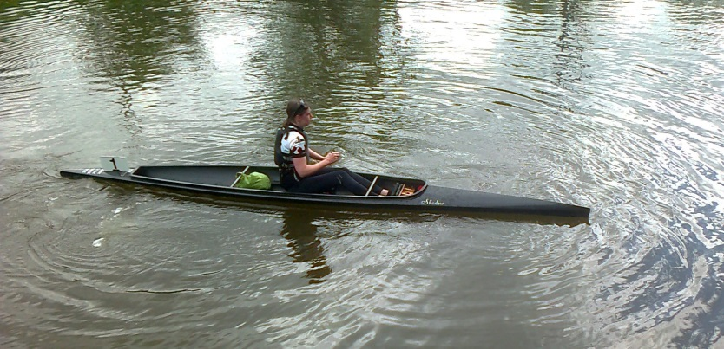 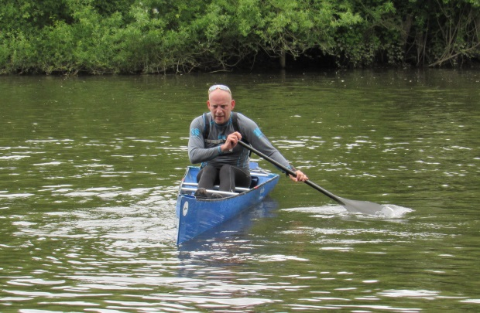



*🡨 end 🡪*